Argiroupolis Booking Form

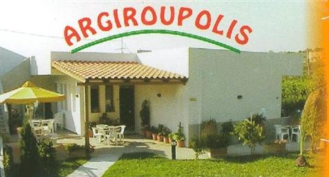If you wish to book, please complete the following sections and either post or fax the form using the details at the bottom of the second page.

This will usually be confirmed by e-mail within two weeks of receipt. Please ensure you provide adequate contact details to enable us to contact you if there is a problem with your booking.

If you want to contact us with a query please don’t hesitate to e-mail us at info@argirouplis.co.uk or using the contact details at the bottom of the page.

A. Your contact details

Name:

Address:

Tel:

Email:

Fax (optional):

B. Room Booking

 | Date  (dd/mm/yyyy) | Duration of Stay  (days) | Approximate time of arrival (if known)

Arrival
Departure |  |  | N/A

Type of bedroom | Number of rooms | Air conditioning*
Two bedroom |  | Yes / No
Three bedroom |  | Yes / No

*Rooms with air-conditioning are €5 (£3 approx) extra per night

Room rates for 2006

Type of bedroom | Prices in low season | Prices in high season
2 bedroom | €35 (£23* approx) | €45 (£30* approx)
3 bedroom | €45 (£30* approx) | €55 (£37* approx)

*Room charges are per room, per night. All rooms are priced in Euros, prices listed in British Pounds on this website are for guidance only, and will vary depending on the exchange rate on the day of checkout.

Low Season= January, February, March, May, October, December

High Season= April, June, July, August, September

The Exchange Rate

1 Euro (€) = 0.6874 British Pounds (£) as at 1st January 2006

C. Transportation (optional)

Should you wish to be collected from your point of entry by the hotel manager please complete the below section.

Travel to/from Airports

 | Date  (dd/mm/yyyy) | Airport | Airline | Flight Number | Scheduled Time | Cost
Arrival |  | Chania/Heraklion |  |  |  | €100
Departure |  | Chania/Heraklion |  |  |  | €100

-or-

Travel to/from Harbour

 | Date  (dd/mm/yyyy) | Harbour | Ferry | Scheduled Time | Cost
Arrival |  | Souda |  |  | €100
Departure |  | Souda |  |  | €100

D. Other Requests

E. Booking fee

All successful bookings incur a non-refundable booking fee of £5 GBP. This covers our UK agency costs, and provides you with unlimited English language support and advice related to your holiday in Crete.

In the event that your booking is unsuccessful your payment will be returned unpaid.

Any fax bookings must be followed by payment within two weeks for your booking to remain valid. Unfortunately we are unable to accept credit cards except via our website.

Payment should be made to: Aikaterini Pateraki by cheque or postal order to the address below-

Contact details
Aikaterini Pateraki

Address:
Argiroupolis Bookings
68 Whitehill Rd,
Cambridge
CB5 8LX

Fax no: 0870 7058926 (UK only)
Email: aikaterini@argiroupolis.co.uk

